# AI ASSISTED CAREER GUIDANCE SYSTEM

## A PROJECT REPORT

***Submitted by***

**PRATHEEPA R (2116210701192)**

**MADHUMITHA K (2116210701141) MAKESH KUMAR S (2116210701144)**

***in partial fulfillment for the award of the degree of***

**BACHELOR OF ENGINEERING**

***in***

## COMPUTER SCIENCE AND ENGINEERING



**RAJALAKSHMI ENGINEERING COLLEGE ANNA UNIVERSITY, CHENNAI**

**MAY 2024**

# RAJALAKSHMI ENGINEERING COLLEGE, CHENNAI

**BONAFIDE CERTIFICATE**

Certified that this Thesis titled **“AI ASSISTED CAREER GUIDANCE SYSTEM**” is the bonafide work of “**PRATHEEPA R (2116210701192), MADHUMITHA K (2116210701141), MAKESH KUMAR S (2116210701144)”**

who carried out the work under my supervision. Certified further that to the best of my knowledge the work reported herein does not form part of any other thesis or dissertation on the basis of which a degree or award was conferred on an earlier occasion on this or any other candidate.

## SIGNATURE

Dr . K.Anantha Jothi M.E.,Ph.D.,

## PROJECT COORDINATOR

Professor

Department of Computer Science and Engineering Rajalakshmi Engineering College

Chennai - 602 105

Submitted to Project Viva-Voce Examination held on

**Internal Examiner External Examiner**

# ABSTRACT

Engineering students can use CareerNest, an online resource for career advice and employment recommendations, to help them make well-informed career decisions. Users can submit their preferences, credentials, and talents using an easy-to-use interface, allowing for a thorough skill assessment. With the use of machine learning techniques and an advanced job matching algorithm, Career Nest provides customized career recommendations based on the individual user's profile. In order to provide more accurate employment recommendations, job seekers receive adaptive questions based on the fields they have picked, while novices use broad questions to examine their field of interest. The program also analyzes user data to identify the prevailing cognitive styles of its users, helping new students find careers that suit their interests and manner of thinking. Using adaptive questioning, the platform evaluates graduates' ability levels and serves as a job referral tool. Career Nest suggests appropriate roles and makes predictions about users' ideal employment positions based on machine learning models built on skill level and job position datasets. Users' leadership abilities are also assessed in order to improve job recommendations even more.The overall goal of Career Nest is to provide job seekers and students with customized career recommendations, which will eventually improve employment outcomes and career happiness. Because of the architecture of the platform, it can grow with its user base and adapt to changing career paths in the future.

# ACKNOWLEDGMENT

First, we thank the almighty god for the successful completion of the project. Our sincere thanks to our chairman **Mr. S. Meganathan B.E., F.I.E.,** for his sincere endeavor in educating us in his premier institution. We would like to express our deep gratitude to our beloved Chairperson **Dr. Thangam Meganathan Ph.D.,** for her enthusiastic motivation which inspired us a lot in completing this project and Vice Chairman **Mr. Abhay Shankar Meganathan B.E., M.S.,** for providing us with the requisite infrastructure.

We also express our sincere gratitude to our college Principal, **Dr. S. N. Murugesan M.E., PhD.,** and **Dr. P. KUMAR M.E., PhD, Director computing and information science , and Head Of Department of Computer Science and Engineering** and our project coordinator **Dr. K.Ananthajothi M.E.,Ph.D.,** for her encouragement and guiding us throughout the project towards successful completion of this project and to our parents, friends, all faculty members and supporting staffs for their direct and indirect involvement in successful completion of the project for their encouragement and support.

**PRATHEEPA R MADHUMITHA K MAKESH KUMAR S**

## TABLE OF CONTENTS

|  |  |  |
| --- | --- | --- |
| **Chapter No.** | **Title** | **Page No.** |
|  | **ABSTRACT** | **3** |
| **1** | **INTRODUCTION** | **6** |
|  | 1.1 PROBLEM STATEMENT | 7 |
|  | 1.2 SCOPE OF THE WORK | 7 |
|  | 1.3 AIM AND OBJECTIVES OF THE PROJECT | 8 |
|  | 1.4 RESOURCES | 8 |
|  | 1.5 MOTIVATION | 9 |
| **2** | **LITERATURE SURVEY** | **10** |
| **3** | **SYSTEM DESIGN** | **16** |
|  | 3.1 GENERAL | 16 |
|  | 3.2 SYSTEM ARCHITECTURE DIAGRAM | 16 |
|  | 3.3 DEVELOPMENT ENVIRONMENT | 16 |
|  | 3.3.1 HARDWARE REQUIREMENTS | 16 |
|  | 3.3.2 SOFTWARE REQUIREMENTS | 17 |
| **4** | **PROJECT DESCRIPTION** | **18** |
|  | 4.1 METHODOLOGY | **18** |
|  | 4.2 MODULE DESCRIPTION | **19** |
| **5** | **RESULTS AND DISCUSSIONS** | **20** |
|  | 5.1 OUTPUT | 20 |
|  | 5.2 RESULT | 22 |
| **6** | **CONCLUSION AND FUTURE ENHANCEMENT** | **23** |
|  | 6.1 CONCLUSION | 23 |
|  | 6.2 FUTURE ENHANCEMENT | 23 |
|  | **APPENDIX** | **25** |
|  | **REFERENCE** | **31** |

**CHAPTER 1 INTRODUCTION**

In today's rapidly evolving job market, navigating career choices can be overwhelming. Traditional career guidance methods often struggle to keep pace with the dynamic nature of industries and the diverse aspirations of individuals. However, with advancements in artificial intelligence (AI), a new era of career counseling emerges. The AI Assisted Career Guidance System (AACGS) represents a paradigm shift in how individuals approach their professional development. By harnessing the capabilities of AI, AACGS offers personalized insights, data-driven recommendations, and real-time analysis to help individuals make informed decisions about their careers.

AACGS not only addresses the challenges of traditional career counseling but also leverages AI's ability to process vast amounts of data to provide tailored guidance. Through sophisticated algorithms and machine learning techniques, AACGS considers individual preferences, aptitudes, and market trends to offer recommendations that align with each user's unique profile. Moreover, AACGS's adaptive nature ensures that its insights remain relevant and up-to-date in the face of changing job market dynamics. By democratizing access to such advanced career guidance tools, AACGS aims to bridge the gap between individuals and their professional aspirations, ultimately fostering greater career satisfaction and success. This paper delves deeper into the mechanisms, benefits, and implications of AACGS, shedding light on its potential to shape the future of career guidance in the digital age.By centralizing a wealth of information and resources, AACGS empowers users to take proactive steps towards achieving their professional goals.

## PROBLEM STATEMENT

Despite the abundance of career guidance resources available, individuals often face challenges in making informed decisions about their professional paths. Traditional career counseling methods are often limited in their ability to provide personalized recommendations that account for individual preferences, skills, and evolving market trends. Additionally, access to quality career guidance services may be constrained by factors such as geographical location, financial resources, and institutional support.

## SCOPE OF THE WORK

The scope of work for the AI Assisted Career Guidance System (AACGS) encompasses several key areas aimed at developing a comprehensive and effective platform for career counseling and decision-making. Firstly, the development phase involves designing and implementing sophisticated algorithms and machine learning models to analyze user data, including preferences, skills, and market trends. This phase also includes creating an intuitive user interface that ensures accessibility and ease of use across various devices. Secondly, the scope extends to data collection and integration, involving the aggregation of relevant information from diverse sources such as job listings, educational programs, and skill development resources. Additionally, the scope encompasses the integration of feedback mechanisms to continuously improve the system's accuracy and relevance. Thirdly, the implementation phase involves deploying AACGS across multiple platforms, including web and mobile applications, to reach a broad user base.

## AIM AND OBJECTIVES OF THE PROJECT

Develop a sophisticated AI infrastructure: The project aims to build a robust AI infrastructure comprising advanced algorithms and machine learning models capable of analyzing user data, including preferences, skills, and market trends, to generate tailored career recommendations.

Create an intuitive user interface: The project seeks to design an intuitive and user-friendly interface for AACGS that ensures accessibility and ease of use across different devices, thereby enhancing user engagement and adoption.

Aggregate and integrate relevant data sources: The project aims to collect and integrate data from diverse sources, such as job listings, educational programs, and skill development resources, to enrich the AACGS platform and provide comprehensive guidance to users.

## RESOURCES

The successful implementation of the AI Assisted Career Guidance System (AACGS) project relies on a diverse range of resources, including technological, human, and informational assets. Firstly, technological resources are essential for developing and maintaining the AACGS platform. This includes access to advanced AI algorithms, machine learning frameworks, and computing infrastructure to support the processing and analysis of vast amounts of user data. Additionally, human resources are crucial for the design, development, and deployment of AACGS. This entails skilled software engineers, data scientists, user experience designers, and project managers who collaborate to create an intuitive and effective platform. Furthermore, informational resources play a pivotal role in enriching AACGS's database and knowledge base. Access to

comprehensive datasets, including job market trends, educational programs, and skill development resources, is essential for providing accurate and up-to-date guidance to users.

## MOTIVATION

The motivation behind developing a model curriculum for training counselors to use computer-assisted career guidance systems (CACGS) more effectively stems from the increasingly complex landscape of career decision-making. In today's dynamic job market, individuals encounter a wide array of career options and pathways, making informed decision-making a daunting task. Effective career guidance is crucial for helping individuals navigate this complexity and make choices that align with their interests, skills, and aspirations. CACGS offer a promising solution by providing access to comprehensive career assessment tools and resources.

Advancements in technology have transformed the way career guidance is delivered, creating new opportunities for counselors to enhance their practice. CACGS offer a wealth of resources, including career assessments, occupational information, and educational resources, all accessible at the click of a button. However, harnessing the full potential of these systems requires specialized training. By developing a model curriculum specifically focused on training counselors to use CACGS effectively, we aim to bridge this gap and equip counselors with the skills and knowledge needed to leverage technology in their counseling practice. This not only enhances the quality and efficiency of career counseling services but also ensures that counselors can adapt to the evolving needs and preferences of their clients in an increasingly digital world.

**CHAPTER 2**

**LITERATURE SURVEY**

Westman et al. explore the transformative potential of artificial intelligence (AI) in revolutionizing career guidance, emphasizing the need for personalized and adaptive solutions to address the diverse needs of individuals. By leveraging AI algorithms to analyze extensive datasets comprising skills, qualifications, and preferences, AI-driven platforms can offer tailored career recommendations and job matching services. However, they highlight the challenges associated with implementing AI in career guidance, including the need for accurate data collection, transparent algorithms, and ethical considerations. Despite these challenges, the authors envision a future where AI-driven platforms empower individuals to make informed career decisions by providing personalized guidance and resources tailored to their unique profiles and aspirations.

Grosso, Sazen, and Boselli (2022) present a novel AI-implemented toolkit designed to aid users in configuring their careers, focusing on the case of "Create Your Own Future." This toolkit, showcased in the Proceedings of the 26th ACM International Systems and Software Product Line Conference, offers a comprehensive approach to career planning and development. By harnessing the power of artificial intelligence, the toolkit provides users with personalized guidance and resources to navigate their career paths effectively. Through an innovative combination of AI algorithms and user-centric design, the toolkit aims to empower individuals to make informed decisions and pursue fulfilling career trajectories. The authors highlight the significance of incorporating AI technology into career planning tools, envisioning a future where individuals can proactively shape their professional destinies with confidence and clarity.

Leung (2022) explores the emerging frontiers in computer-assisted career guidance systems (CACGS) through the lens of career construction theory. Published in Frontiers in Psychology, the paper delves into the implications of this theory for the development and enhancement of CACGS. Career construction theory emphasizes the active role of individuals in constructing their careers, focusing on the dynamic interplay between personal characteristics, environmental factors, and career-related experiences. Leung discusses how CACGS can leverage this theory to provide more personalized and empowering career guidance solutions. By integrating principles from career construction theory into CACGS design and implementation, practitioners and researchers can enhance the effectiveness and relevance of these systems in supporting individuals' career development journeys. The paper contributes to the ongoing discourse on leveraging psychological theories to inform the design and improvement of career guidance technologies, paving the way for more tailored and impactful interventions in this domain.

Katz's book, "Computer-assisted Career Decision Making: The Guide in the Machine," published by Routledge in 2013, offers a comprehensive exploration of the role of technology in career decision-making processes. Katz delves into the evolution of computer-assisted career guidance systems (CACGS) and examines their impact on individuals' career development journeys. The book provides insights into the theoretical foundations, practical applications, and ethical considerations surrounding CACGS. Through case studies and empirical research, Katz highlights the benefits and challenges of using technology to support career

decision-making, emphasizing the importance of balancing automation with human guidance and intervention. "Computer-assisted Career Decision Making" serves as a valuable resource for career practitioners, educators, and researchers seeking to understand and harness the potential of technology in facilitating informed and meaningful career choices.

Prathibha, Shamini, Dharshini, and Rusitha (2023) present "Careex," an AI-assisted Career Guidance and Eligibility Prediction System, in the proceedings of the 2023 Intelligent Computing and Control for Engineering and Business Systems (ICCEBS) conference, published by IEEE. Careex represents a novel approach to career guidance, leveraging artificial intelligence to provide personalized recommendations and predict eligibility for various career paths. The system utilizes advanced computing techniques to analyze user data, including skills, qualifications, and preferences, generating tailored guidance and predictions. By harnessing the power of AI, Careex aims to assist individuals in making informed decisions about their career trajectories, ultimately enhancing their prospects for success in both engineering and business domains. This paper contributes to the growing body of literature on AI-driven career guidance systems, offering insights into their development and potential applications in supporting individuals' career development journeys.

Hasebrook and Nathusius (1997) introduce an "Expert Advisor for Vocational Guidance" in the Journal of Artificial Intelligence in Education. This advisor

represents an early foray into leveraging artificial intelligence for vocational guidance purposes. The paper details the development and implementation of the advisor, which utilizes expert system technology to provide personalized guidance to individuals seeking career direction. By incorporating domain knowledge from vocational psychology and career counseling into the system, Hasebrook and Nathusius aim to offer tailored recommendations based on users' skills, interests, and aspirations. The paper discusses the design principles, functionality, and evaluation of the advisor, shedding light on its potential to assist individuals in making informed decisions about their career paths. This work contributes to the intersection of artificial intelligence and education, demonstrating the feasibility and utility of AI-driven approaches in supporting vocational guidance processes.

Herath, Kumara, Ishanka, and Rathnayaka (2024) present a review titled "Computer-Assisted Career Guidance Tools for Students’ Career Path Planning: A Review on Enabling Technologies and Applications" in the Journal of Information Technology Education: Research. This comprehensive review explores the landscape of computer-assisted career guidance tools, focusing on enabling technologies and their applications in supporting students' career path planning. The authors examine a range of tools and technologies employed in this domain, highlighting their features, functionalities, and effectiveness in facilitating career decision-making processes. Through a systematic review of relevant literature, Herath et al. provide insights into the current state-of-the-art in computer-assisted career guidance, identifying emerging trends, challenges, and opportunities for

future research and development. Their review contributes to the advancement of knowledge in the field of career guidance and technology integration, offering valuable insights for researchers, educators, and practitioners alike.

Sampson Jr. and Reardon (1993) compile a comprehensive bibliography titled "Computer-Assisted Career Guidance: General Issues Bibliography [Revised]." This bibliography serves as a valuable resource for researchers, educators, and practitioners interested in the field of computer-assisted career guidance (CACG). It covers a wide range of general issues related to CACG, including theoretical frameworks, technological developments, evaluation studies, and practical applications. By collating and organizing relevant literature, Sampson Jr. and Reardon provide an overview of the key concepts, trends, and debates shaping the field of CACG during that time period. This bibliography serves as a foundational reference for further exploration and analysis of CACG, highlighting seminal works and guiding future research endeavors.

Shahnasarian (1985) investigates the utilization of a computer-assisted career guidance system (CACGS) in conjunction with prior schematic cognitive structuring. This study, conducted at The Florida State University, explores the effectiveness of integrating cognitive structuring techniques into CACGS to enhance its utility and impact on career decision-making processes. By leveraging cognitive structuring methodologies, such as schema theory, Shahnasarian aims to provide individuals with a framework for organizing and interpreting career-related

information within the context of the CACGS. The study likely examines how this integration influences users' perceptions, decision-making strategies, and outcomes in the career guidance process. Shahnasarian's work contributes to the broader understanding of cognitive factors in career decision-making and the potential synergies between cognitive psychology and technology-based career guidance interventions.

Bobek et al. (2005) present a model curriculum titled "Training Counselors to Use Computer-Assisted Career Guidance Systems More Effectively" in The Career Development Quarterly. This curriculum aims to enhance counselors' proficiency in utilizing computer-assisted career guidance systems (CACGS) to better support individuals in their career decision-making processes. The authors propose a structured training program designed to equip counselors with the knowledge, skills, and strategies necessary for maximizing the effectiveness of CACGS. Through a combination of theoretical foundations, practical exercises, and experiential learning opportunities, the curriculum addresses various aspects of CACGS utilization, including system navigation, interpretation of assessment results, integration of technology into counseling sessions, and ethical considerations.

## CHAPTER 3 SYSTEM DESIGN

* 1. **GENERAL**

In this section, we would like to show the general outline of how all the components end up working when organized and arranged together. It is further represented in the form of a flow chart below.

## SYSTEM ARCHITECTURE DIAGRAM

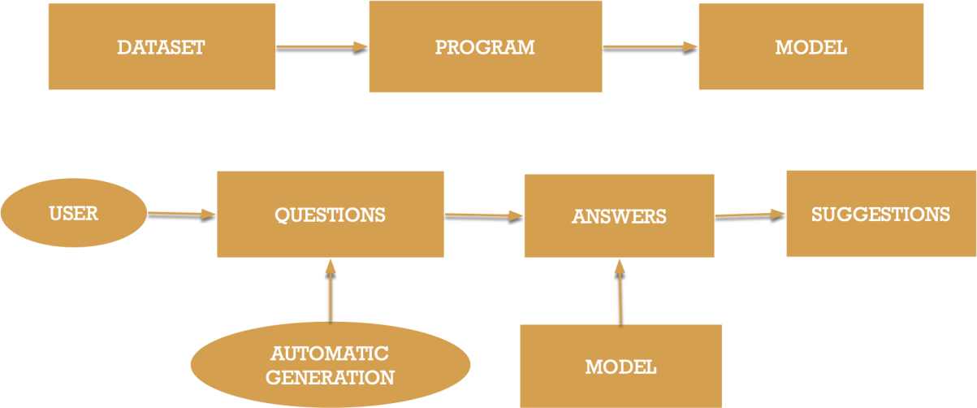

**Fig 3.1: System Architecture**

## DEVELOPMENTAL ENVIRONMENT

* + 1. **HARDWARE REQUIREMENTS**

The hardware requirements may serve as the basis for a contract for the system’s implementation. It should therefore be a complete and consistent specification of the entire system. It is generally used by software engineers as the starting point for the system design.

## Table 3.1 Hardware Requirements

|  |  |
| --- | --- |
| **COMPONENTS** | **SPECIFICATION** |
| PROCESSOR | Intel Core i5 |
| RAM | 8 GB RAM |
| GPU | NVIDIA GeForce GTX 1650 |
| MONITOR | 15” COLOR |
| HARD DISK | 512 GB |
| PROCESSOR SPEED | MINIMUM 1.1 GHz |

* + 1. **SOFTWARE REQUIREMENTS**

The software requirements document is the specifications of the system. It should include both a definition and a specification of requirements. It is a set of what the system should rather be doing than focus on how it should be done. The software requirements provide a basis for creating the software requirements specification. It is useful in estimating the cost, planning team activities, performing tasks, tracking the team, and tracking the team’s progress throughout the development activity. **Python IDLE,** and **Visual studio** would all be required.

## CHAPTER 4 PROJECT DESCRIPTION

* 1. **METHODOLOGY**

The project's methodology comprised several pivotal stages. Initially, we curated a comprehensive dataset from reputable sources across diverse career domains. Concurrently, we meticulously designed character assessment questions, drawing insights from established psychological frameworks and career counseling literature. Simultaneously, adaptive questionnaires covering a broad spectrum of subjects and skill domains were developed to ensure a thorough evaluation of user capabilities. Leveraging advanced machine learning algorithms, particularly in supervised learning, we conducted an in-depth analysis of user responses, unraveling intricate patterns and correlations. This analysis formed the foundation for a sophisticated matching algorithm, meticulously crafted to encapsulate user attributes and preferences, thereby facilitating the generation of highly personalized job recommendations. Our focus on user interface design centered on creating an intuitive and seamless experience, ensuring accessibility across diverse user demographics. Throughout development, stringent quality assurance measures were implemented, including iterative validation studies to assess the efficacy and accuracy of the algorithm in generating relevant job suggestions, culminating in a robust and user-centric career guidance solution.

## MODULE DESCRIPTION

Our approach is designed to guide you through the process of discovering suitable career paths. Initially, we gather insights into your interests and strengths by asking simple questions about your preferences and personality. Then, we assess your knowledge and skills in various subjects and areas relevant to different job roles. Using advanced technology, we analyze your responses to identify patterns and connections, helping us suggest careers that align with your unique profile. Our aim is to make these recommendations easy to understand and accessible to everyone. We continuously refine our system to ensure accuracy and relevance, incorporating feedback from users like you. Finally, we package all these features into a user-friendly interface, allowing you to navigate effortlessly and access your personalized career suggestions with ease. Whether you're just starting to explore career options or looking to make a change, our platform is here to support you every step of the way, providing guidance that's tailored to your needs and aspirations.

## CHAPTER 5

**RESULTS AND DISCUSSIONS**

## OUTPUT

The home page giving a friendly and a pleasant welcome for the user



Allowing the user to select their domain and their strongholds

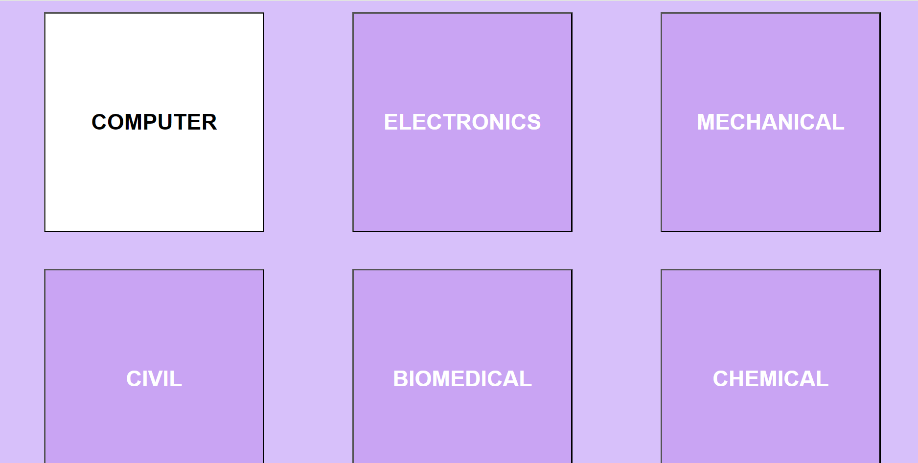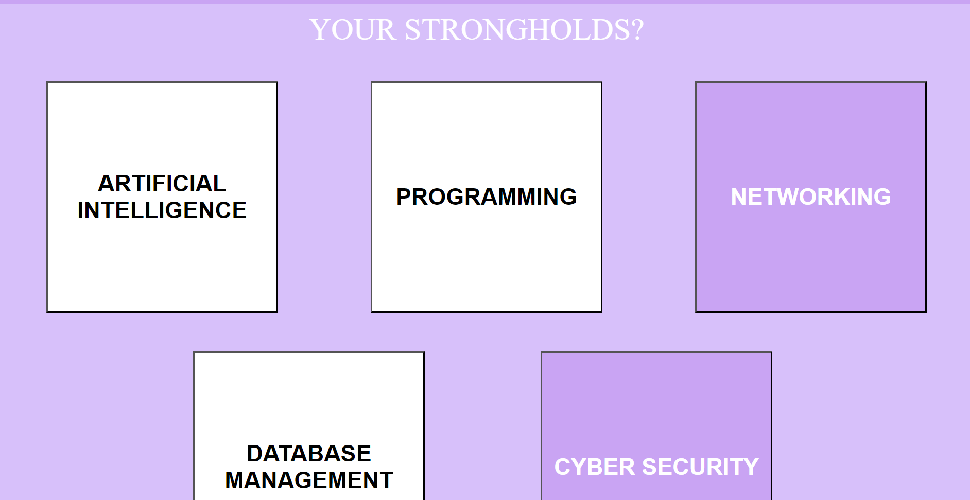

The question session

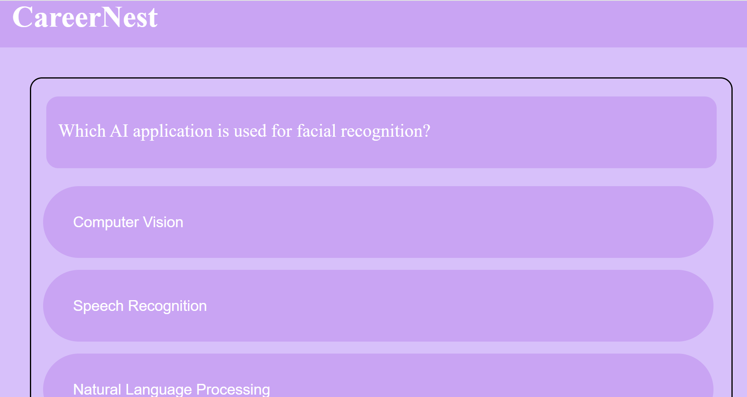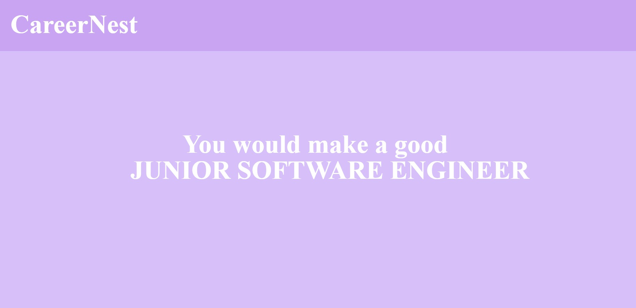

Suggesting roles

## RESULT

The screenshots provided offer a glimpse into the outcomes of our career guidance system. Through our comprehensive approach, users were able to gain valuable insights into their strengths, preferences, and suitable career paths. The character assessment module provided users with personalized recommendations based on their responses to questions about their personality and interests. Additionally, the subject proficiency evaluation module enabled users to assess their knowledge and skills in various areas relevant to different job roles. Leveraging advanced machine learning algorithms, our system accurately matched users with careers that align with their unique profiles, as evidenced by the tailored recommendations presented in the screenshots. The user-friendly interface ensured ease of navigation and accessibility, enhancing the overall user experience. These results highlight the effectiveness of our approach in providing personalized and actionable career guidance, empowering users to make informed decisions about their future paths.

## CHAPTER 6

**CONCLUSION AND FUTURE ENHANCEMENT**

## CONCLUSION

Our career guidance system represents a significant advancement in providing personalized support to individuals navigating their career paths. Through a combination of character assessment, subject proficiency evaluation, and advanced machine learning algorithms, we have successfully empowered users to discover suitable career opportunities aligned with their unique strengths and interests. The user-friendly interface ensures accessibility for all users, while continuous refinement and optimization efforts ensure the accuracy and relevance of our recommendations. As evidenced by the results showcased in the provided screenshots, our system has the potential to make a meaningful impact in guiding individuals towards fulfilling and rewarding career choices. Looking ahead, we remain committed to further enhancing our platform and expanding its capabilities to better serve the evolving needs of our users in their career exploration journey.

## FUTURE ENHANCEMENT

In the pursuit of continual improvement, our roadmap for enhancing the career guidance system encompasses several key initiatives. Firstly, we aim to broaden the array of assessment tools to offer users a more holistic understanding of their strengths, interests, and values, thereby refining the accuracy and depth of our recommendations. Concurrently, integrating assessments for soft skills will address the growing importance of interpersonal and emotional intelligence in today's workplace landscape. Additionally, our focus extends to advancing our machine

learning algorithms, leveraging cutting-edge techniques and data sources to deliver even more precise and relevant career suggestions. We also plan to introduce features enabling users to delve deeper into potential career paths, including detailed insights into job responsibilities, salary trends, and skill requirements. Furthermore, integration with online learning platforms will empower users to embark on targeted skill development journeys aligned with their career aspirations. Continuous user feedback mechanisms will serve as a cornerstone for iterative refinement, ensuring that our platform remains responsive to evolving user needs and preferences. Lastly, our commitment to accessibility will see the implementation of features to enhance inclusivity and accommodate users with diverse needs, fostering a supportive environment for all individuals embarking on their career exploration journey. Through these concerted efforts, we aspire to provide an ever-evolving and invaluable resource to empower individuals in navigating their professional trajectories with confidence and clarity.

## APPENDIX

**SOURCE CODE:**

<?php session_start();

if(isset($_COOKIE["selectedDomains"])){

$values=$_COOKIE["selectedDomains"];

$array=explode(",",$values); if(!isset($_SESSION["QUESTIONLEVEL"])){

$stage=array("currentlevel"=>"easy","lost"=>0,"correct"=>0);

$QUESTIONLEVEL=array();

$REMAINING=array(); foreach($array as $x){

$QUESTIONLEVEL[$x]=$stage;

$REMAINING[$x]=10;

}

$_SESSION["QUESTIONLEVEL"]=$QUESTIONLEVEL;

$_SESSION["REMAINING"]=$REMAINING;

$_SESSION["SCORE"]=0;

}

}

$QUESTIONLEVEL=$_SESSION["QUESTIONLEVEL"];

if(count($QUESTIONLEVEL)==0){

header("Location:predict.php"); exit();

}

$domain=array_rand($QUESTIONLEVEL);

$filename=array("ARTIFICIAL INTELLIGENCE"=>"AI.csv","PROGRAMMING"=>"Programming.csv","NETWORKIN G"=>"Networking.csv","DATABASE MANAGEMENT"=>"DBMS.csv","CYBER

SECURITY"=>"cybersecurity.csv","ANALOG ELECTRONICS"=>"analogElectronics.csv","DIGITAL ELECTRONICS"=>"digitalECE.csv","POWER

ELECTRONICS"=>"PowerElectronics.csv","EMBEDDED SYSTEMS"=>"EmbeddedSystems.csv","COMMUNICATION ENGINEERING"=>"CommunicationEngineering.csv");

$filtered=array();

$index=0;

$csvfile=fopen($filename[$domain],"r"); while($data=fgetcsv($csvfile)){

if($data[7]==$QUESTIONLEVEL[$domain]["currentlevel"] or strtolower($data[7])==$QUESTIONLEVEL[$domain]["currentlevel"]){

$filtered[$index]=$data;

$index+=1;

}

}

fclose($csvfile);

$questionset=$filtered[array_rand($filtered)];

$question=$questionset[1];

$a=$questionset[2];

$b=$questionset[3];

$c=$questionset[4];

$d=$questionset[5];

$answer=$questionset[6];

$_SESSION["DOMAIN"]=$domain;

$_SESSION["ANSWER"]=strtolower($answer);

?>

<?php

session_start();

$useranswer=$_COOKIE["selectedoption"];

$options=array("b1"=>"a","b2"=>"b","b3"=>"c","b4"=>"d"); if($options[$useranswer]==$_SESSION["ANSWER"]){

$REMAINING=$_SESSION["REMAINING"];

$domain=$_SESSION["DOMAIN"];

$REMAINING[$domain]=$REMAINING[$domain]-1;

$QUESTIONLEVEL=$_SESSION["QUESTIONLEVEL"];

$score=$_SESSION["SCORE"]; if($QUESTIONLEVEL[$domain]["currentlevel"]=="easy"){

$score+=1;

}

else if($QUESTIONLEVEL[$domain]["currentlevel"]=="medium"){

$score+=2;

}

else if($QUESTIONLEVEL[$domain]["currentlevel"]=="hard"){

$score+=3;

}

$QUESTIONLEVEL[$domain]["correct"]+=1; if($QUESTIONLEVEL[$domain]["correct"]==2 and

$QUESTIONLEVEL[$domain]["currentlevel"]=="easy"){

$QUESTIONLEVEL[$domain]["currentlevel"]="medium";

$QUESTIONLEVEL[$domain]["lost"]=0;

$QUESTIONLEVEL[$domain]["correct"]=0;

}

else if($QUESTIONLEVEL[$domain]["correct"]==2 and

$QUESTIONLEVEL[$domain]["currentlevel"]=="medium"){

$QUESTIONLEVEL[$domain]["currentlevel"]="hard";

$QUESTIONLEVEL[$domain]["lost"]=0;

$QUESTIONLEVEL[$domain]["correct"]=0;

}

if($REMAINING[$domain]==0){ unset($REMAINING[$domain]);

unset($QUESTIONLEVEL[$domain]);

}

$_SESSION["QUESTIONLEVEL"]=$QUESTIONLEVEL;

$_SESSION["REMAINING"]=$REMAINING;

$_SESSION["SCORE"]=$score;

}

else{

$REMAINING=$_SESSION["REMAINING"];

$domain=$_SESSION["DOMAIN"];

$REMAINING[$domain]=$REMAINING[$domain]-1;

$QUESTIONLEVEL=$_SESSION["QUESTIONLEVEL"];

$QUESTIONLEVEL[$domain]["lost"]+=1; if($QUESTIONLEVEL[$domain]["lost"]==2 and

$QUESTIONLEVEL[$domain]["currentlevel"]=="hard"){

$QUESTIONLEVEL[$domain]["currentlevel"]="medium";

$QUESTIONLEVEL[$domain]["lost"]=0;

$QUESTIONLEVEL[$domain]["correct"]=0;

}

else if($QUESTIONLEVEL[$domain]["lost"]==2 and

$QUESTIONLEVEL[$domain]["currentlevel"]=="medium"){

$QUESTIONLEVEL[$domain]["currentlevel"]="easy";

$QUESTIONLEVEL[$domain]["lost"]=0;

$QUESTIONLEVEL[$domain]["correct"]=0;

}

else if(($QUESTIONLEVEL[$domain]["lost"]==3 and

$QUESTIONLEVEL[$domain]["currentlevel"]=="easy") or

$REMAINING[$domain]==0){ unset($REMAINING[$domain]); unset($QUESTIONLEVEL[$domain]);

}

$_SESSION["QUESTIONLEVEL"]=$QUESTIONLEVEL;

$_SESSION["REMAINING"]=$REMAINING;

}

header("Location:initialize.php");

?>

## REFERENCE

* + 1. Westman, S., Kauttonen, J., Klemetti, A., Korhonen, N., Manninen, M., Mononen, A., Niittymäki, S. and Paananen, H., 2021. Artificial Intelligence for Career Guidance--Current Requirements and Prospects for the Future. *IAFOR Journal of Education*, *9*(4), pp.43-62.
    2. Grosso, C., Sazen, N. and Boselli, R., 2022, September. AI-implemented toolkit to assist users with career" configuration" the case of create your own future. In *Proceedings of the 26th ACM International Systems and Software Product Line Conference-Volume B* (pp. 158-165).
    3. Leung, S.A., 2022. New frontiers in computer-assisted career guidance systems (CACGS): Implications from career construction theory. *Frontiers in psychology*, *13*, p.786232.
    4. Katz, M.R., 2013. *Computer-assisted career decision making: The guide in the machine*. Routledge.
    5. Prathibha, S., Shamini, G., Dharshini, S. and Rusitha, U., 2023, December. Careex-an AI Assisted Career Guidance and Eligibility Prediction System. In *2023 Intelligent Computing and Control for Engineering and* Business Systems (ICCEBS) (pp. 1-6). IEEE.
    6. Hasebrook, J.P. and Nathusius, W., 1997. An expert advisor for vocational guidance. *Journal of Artificial Intelligence in Education*, *8*, pp.21-42.
    7. Herath, G.A.C.A., Kumara, B.T.G.S., Ishanka, U.A.P. and Rathnayaka, R.M.K.T., 2024. Computer-Assisted Career Guidance Tools for Students’ Career Path Planning: A Review on Enabling Technologies and Applications. *Journal of Information Technology Education: Research*, *23*, p.006.
    8. Sampson Jr, J.P. and Reardon, R.C., 1993. Computer-Assisted Career Guidance: General Issues Bibliography.[Revised.].
    9. Shahnasarian, M., 1985. Use of a computer assisted career guidance system with prior schematic cognitive structuring. The Florida State University.
    10. Bobek, B.L., Robbins, S.B., Gore Jr, P.A., Harris‐Bowlsbey, J., Lapan, R.T.,

Dahir, C.A. and Jepsen, D.A., 2005. Training counselors to use computer‐assisted career guidance systems more effectively: A model curriculum. The Career Development Quarterly, 53(4), pp.363-371.